|  |
| --- |
| YEAR 12 Essentials Mathematics  Semester 1 2018  Test 3 - **Volume, Capacity, 2D & 3D shapes, Scale, plans.**  **.** |
| Total Marks: 55 marks  Name: ______________________ Total Time: 60 minutes |



***Full working out must be shown to get full marks.***

***Attempt all questions***

**Total Time: 60 minutes**

***Resources allowed:***

***1 A4 page, (1 side) of hand written notes, ruler***

***Calculator***

1. Using the correct formula find the volume for each figure [2, 2, 2, 2, 2-10 Marks]

7cm

21 cm



9m

6m

18 m

1. 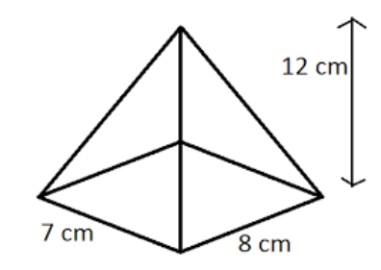

44 m



12cm 14cm

11cm

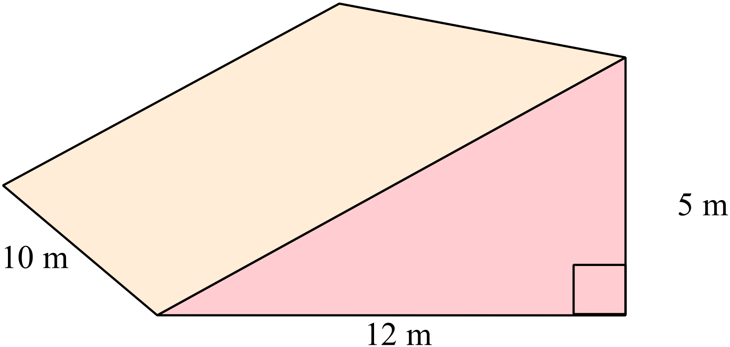

e)

1. Convert the following measurement to the units specified: [1,1,1,1 - 4 marks]

a) 7500 cm3 = m3 b) 0.185 m3 = cm3

c) 9.6 L= cm3 d) 7154 m3 = L

1. Match the nets with the following shapes: [1,1,1,1 - 4 marks]

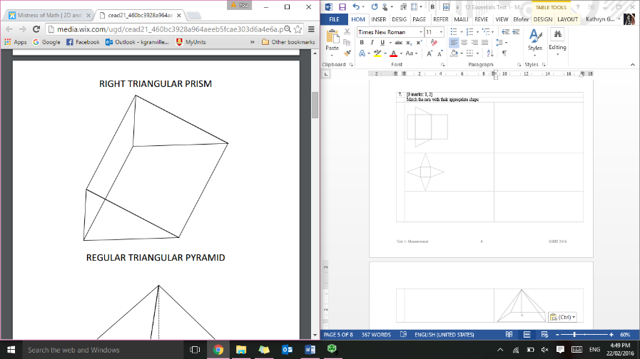

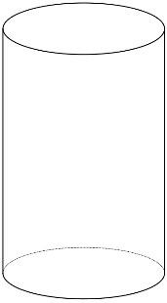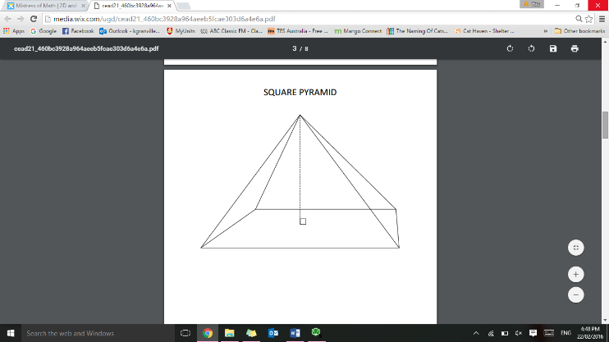

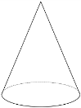

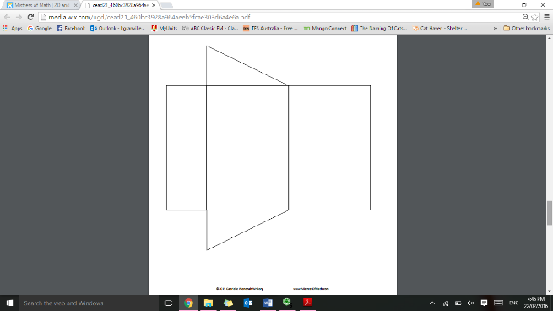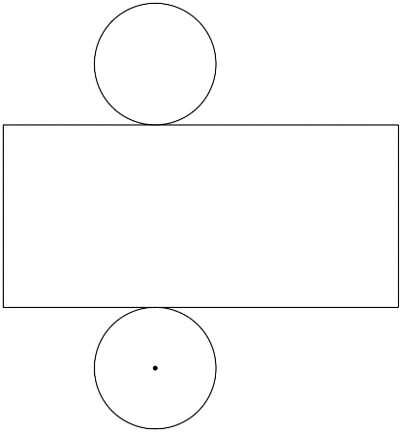

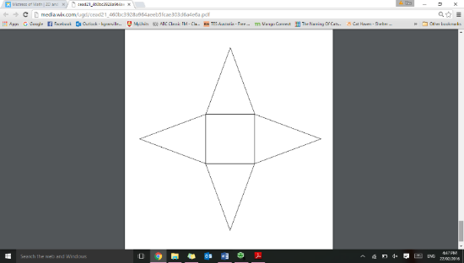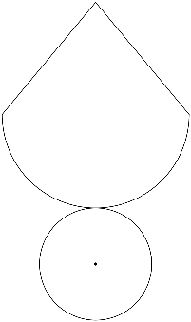

1. Thelma and David built a recycling bin that is 6 meters wide, 12 meters long, and 14 meters high. What volume of trash can fit inside of the bin? [2 Marks]
2. The cylindrical canister of a fire extinguisher has a radius of 4 cm and is 12 cm high. What is the capacity, in litres, of the fire extinguisher? [3 Marks]
3. Cindy went to Maggie Moo’s for an ice cream cone after school. The ice cream cone had a radius of 3 cm, a height of 2 ½ cm, and a slant length of 3 ½ cm, how much ice cream could the cone hold? [3 Marks]
4. Concrete blocks can be used to build houses [3 marks]
   1. Each concrete block measures 45cm by 17cm by 210mm. Calculate the volume of one block.
   2. A wall is made from 80 concrete blocks. Calculate the volume of the wall, in cubic meters?
5. Sketch the following: [2, 2-4 marks]
6. A regular octagon b) An irregular hexagon
7. Consider the polygon ABCDE [1,1,1- 3 marks]

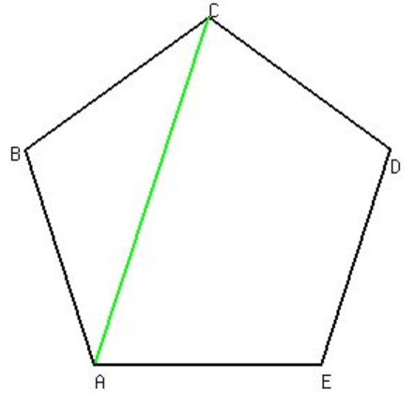

1. State the number of vertices and edges of the polygon
2. Hence, name the polygon
3. The diagonal [AC] is shown using a dashed line. List the other diagonals of the polygon
4. What is the distance between A and B, in meters, using this map? [2 marks]

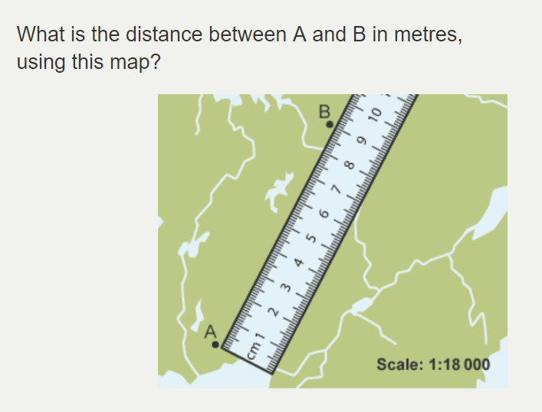

1. Ben is producing a scale diagram of a swimming pool he plans to build. The pool’s dimensions are 2m by 6m. When he measures the drawing of his plan he sees that it is 8cm by 24 cm. What scale should he use on his plan? [2 marks]
2. This sketch shows the side view of a children’s garden house. It consists of an isosceles triangle on top of a rectangle. Make a scale drawing of it using a scale of 1 cm = 30 cm [3 marks]

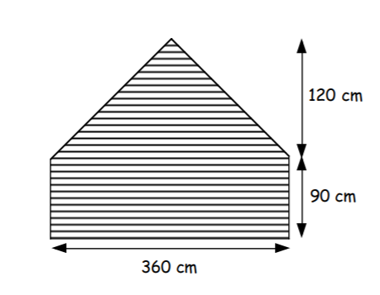

13. Below is the floor plan for Miss Granville’s new holiday house. [3, 2, 5,-10 marks]

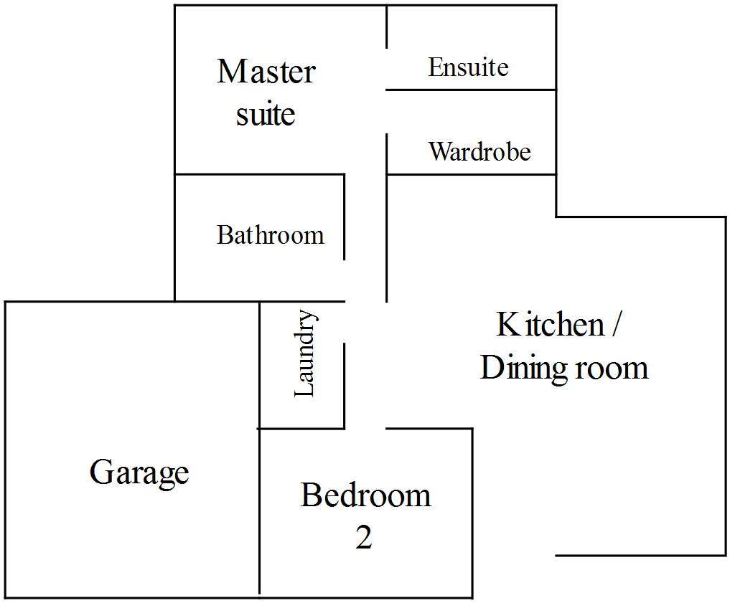

Scale 1:200

* 1. Using the scale given, find the area of the garage in meters2.
  2. Miss Granville decides that she wants to concrete the floor of the garage. If concrete costs $21.20 per square meter, how much will it cost to complete?
  3. The bathroom, laundry and ensuite are to be tiled, with tiles costing $41.40/m2. How much will it cost to buy tiles?

14.An aero plane leaving an airport flew due east for 300 km and due south for 400 km. He then discovered he had engine trouble and decided to fly directly back to the airport. [3 marks]

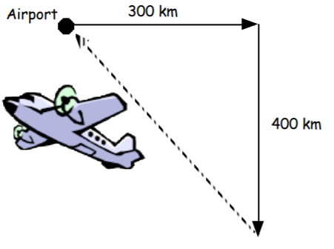

1. Make a scale drawing of the journey using a scale of 1 cm = 100 km.
2. When he began to fly back to the airport the pilot noticed he only had enough fuel to travel 520 km. Can the plane make it back to the airport safely? Explain

End of Test